Jenkins Task
Task Description:
Launch jenkins and explore creating projects and users.

EC2 instance launched.
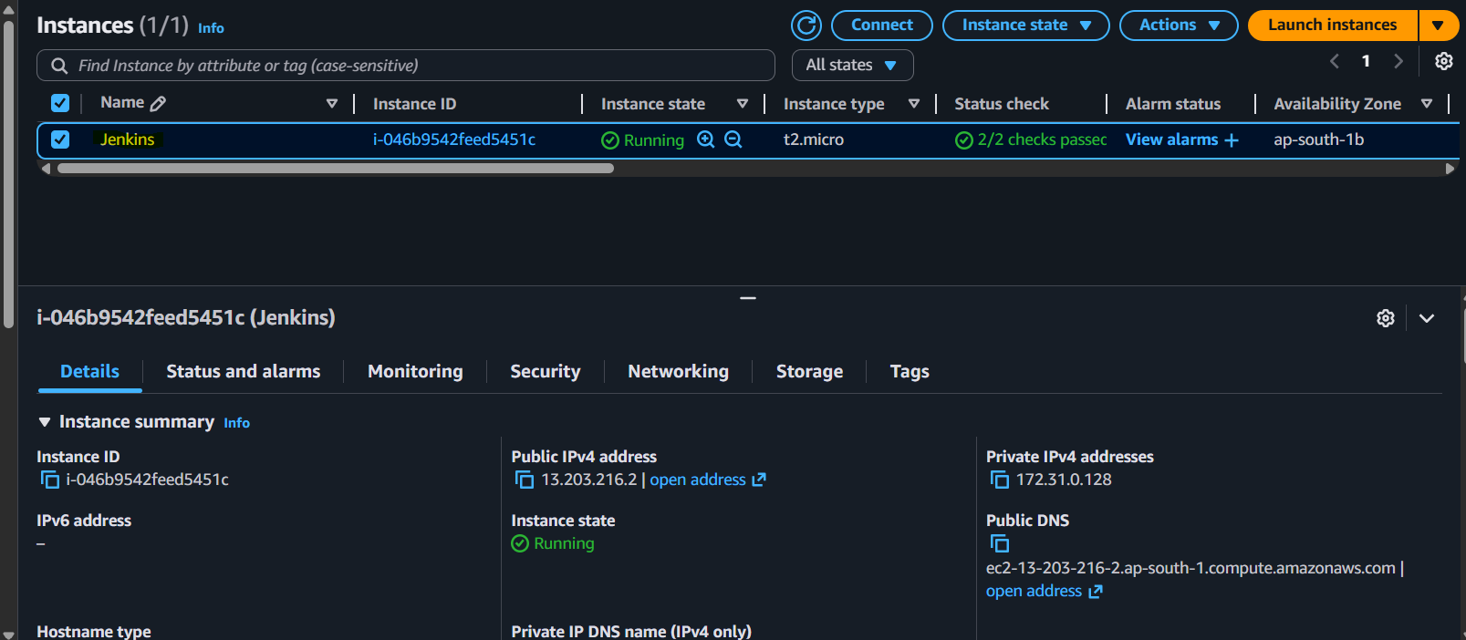

Installation of Java

sudo apt update
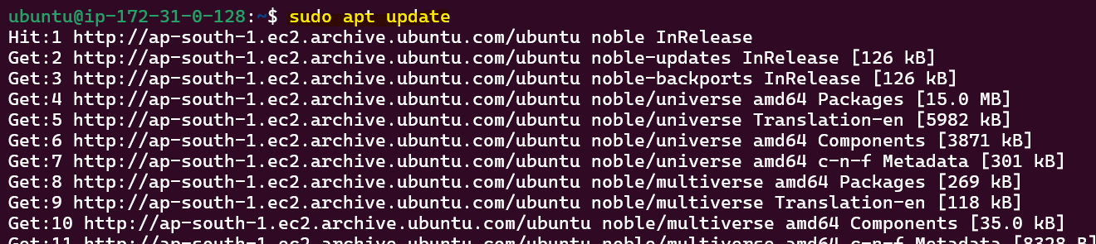

sudo apt install fontconfig openjdk-21-jre
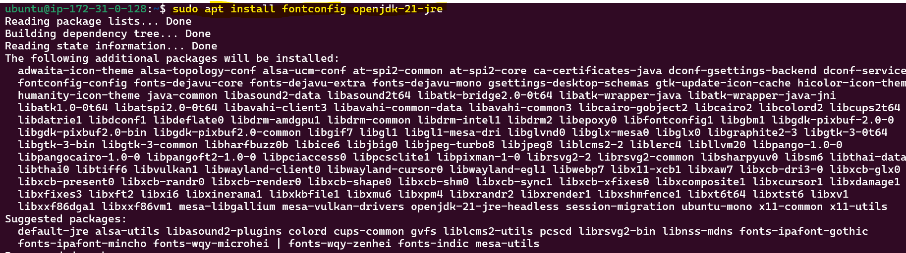

java -version
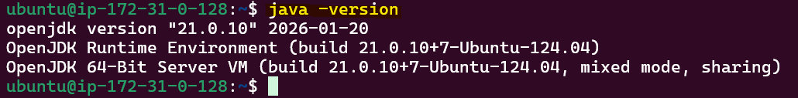

sudo wget -O /etc/apt/keyrings/jenkins-keyring.asc \
https://pkg.jenkins.io/debian-stable/jenkins.io-2026.key
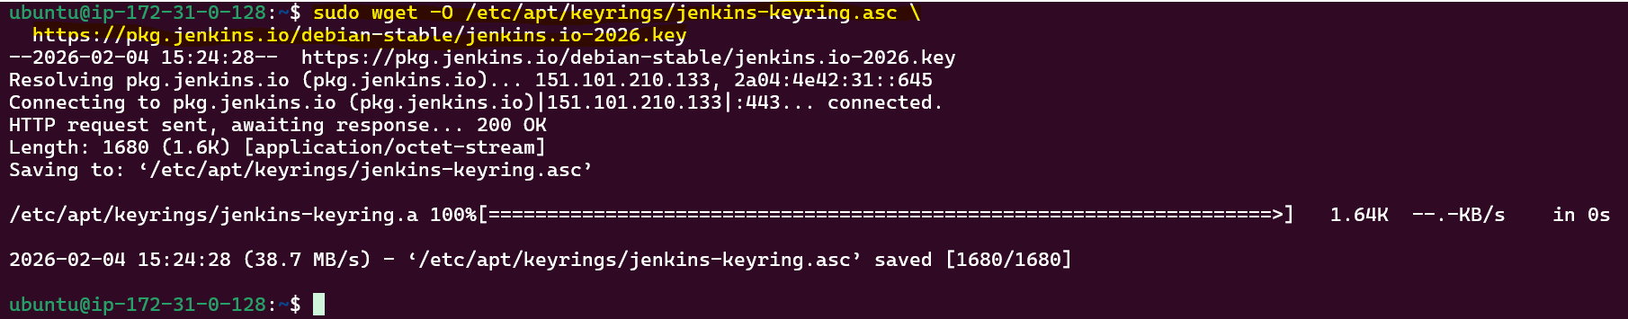
echo "deb [signed-by=/etc/apt/keyrings/jenkins-keyring.asc]" \
https://pkg.jenkins.io/debian-stable binary/ | sudo tee \
/etc/apt/sources.list.d/jenkins.list > /dev/null
sudo apt update
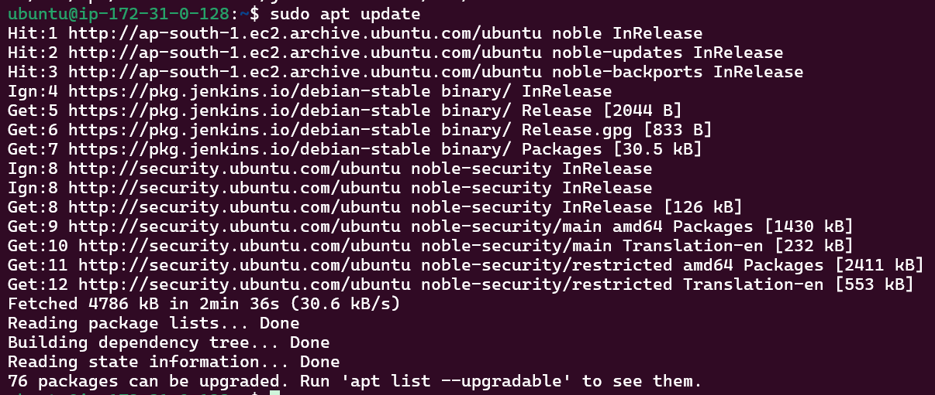
sudo apt install Jenkins
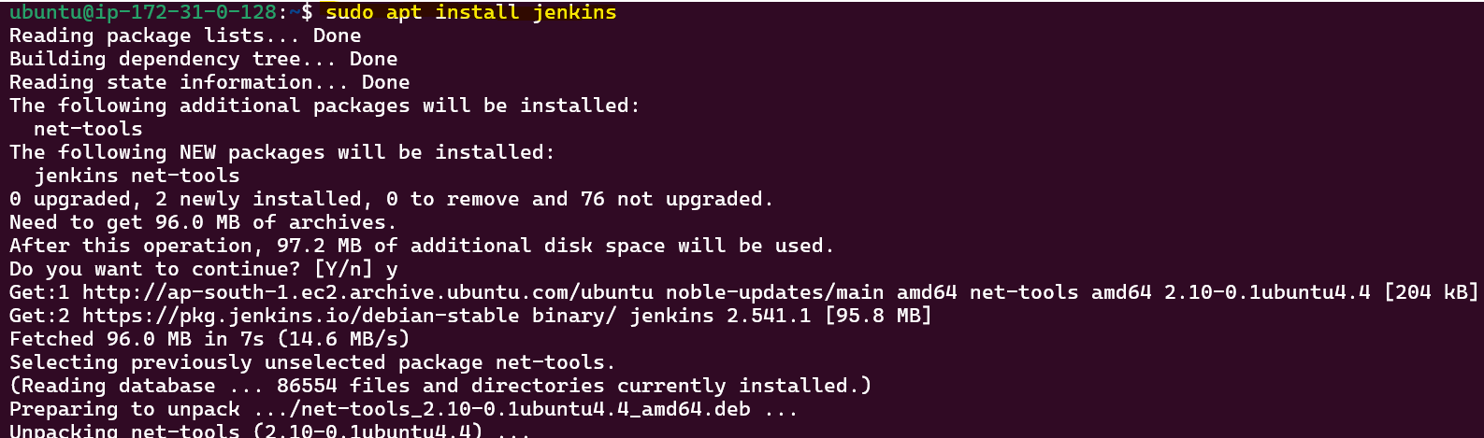
jenkins –version
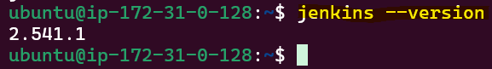

Start the Jenkins
sudo systemctl enable jenkins
sudo systemctl start Jenkins
sudo systemctl status jenkins

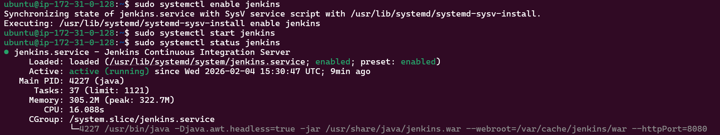

To get the password go to the password path:
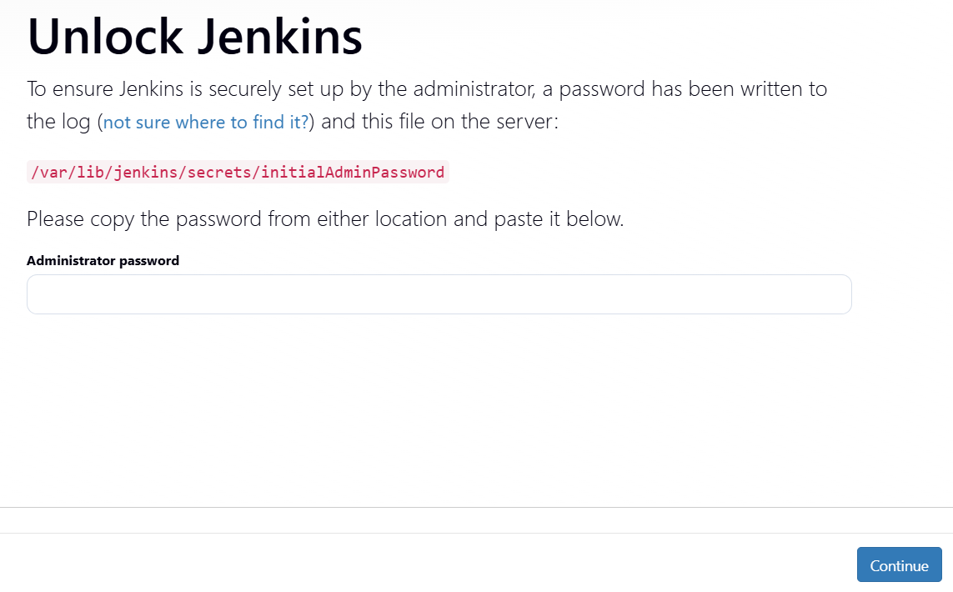

Click on install suggest plugins.
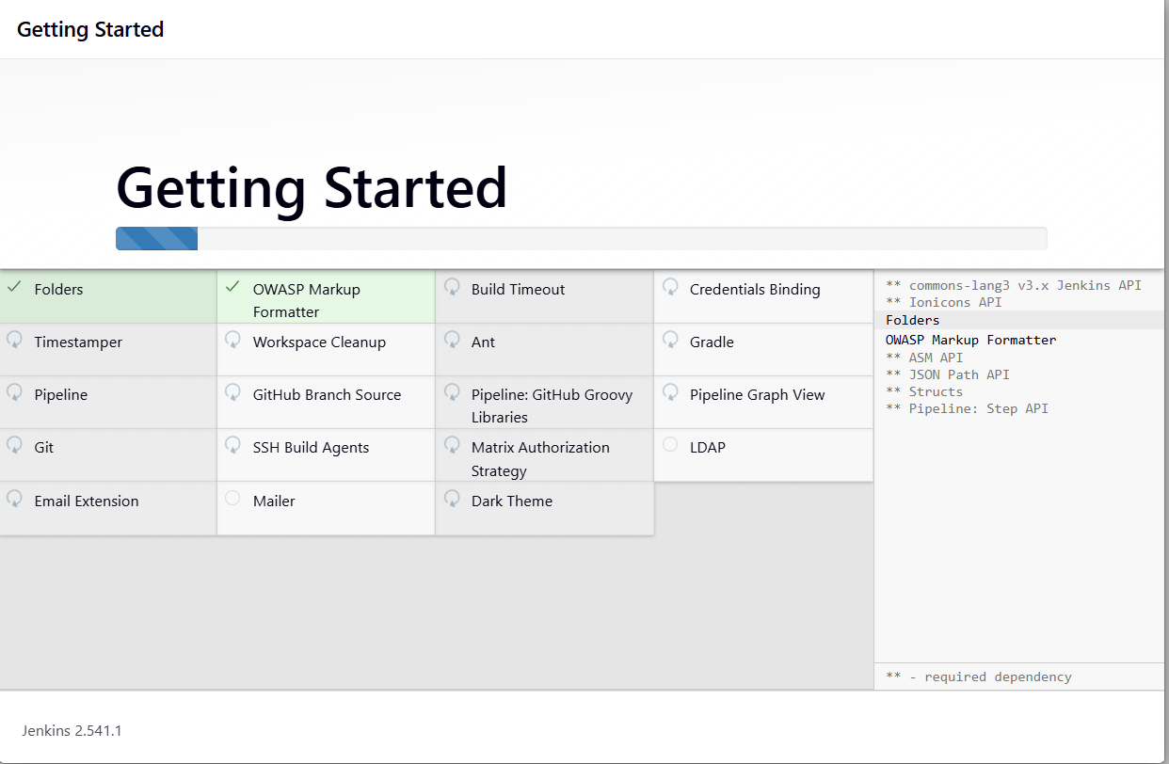
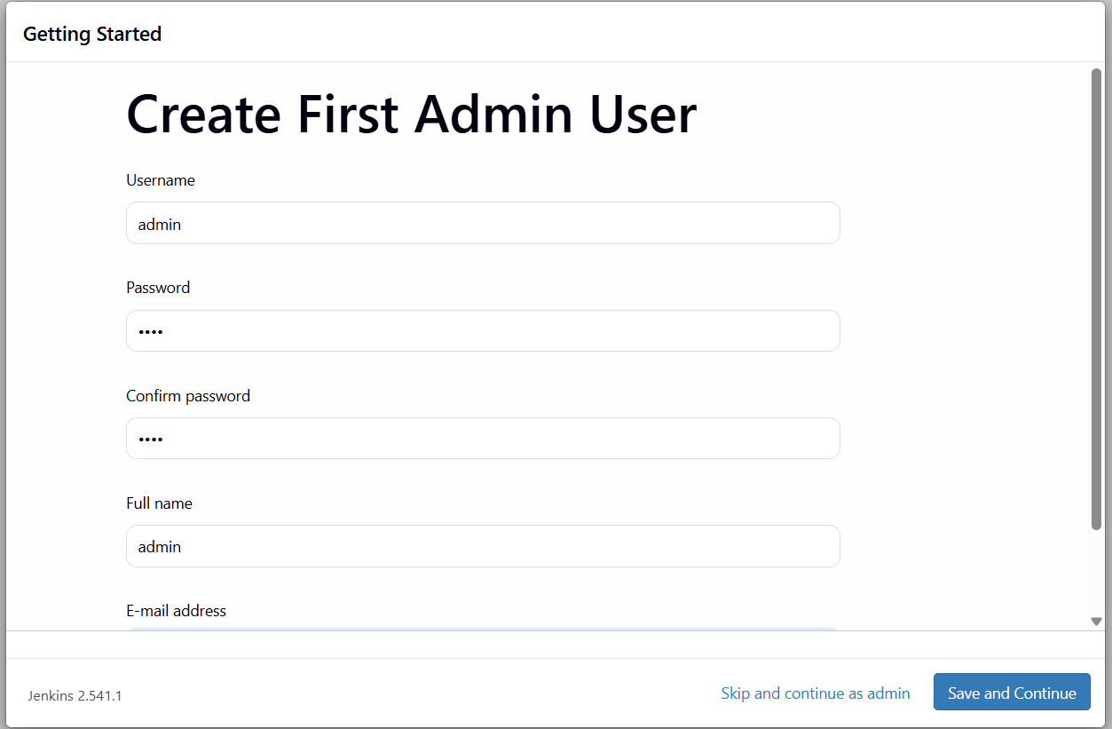

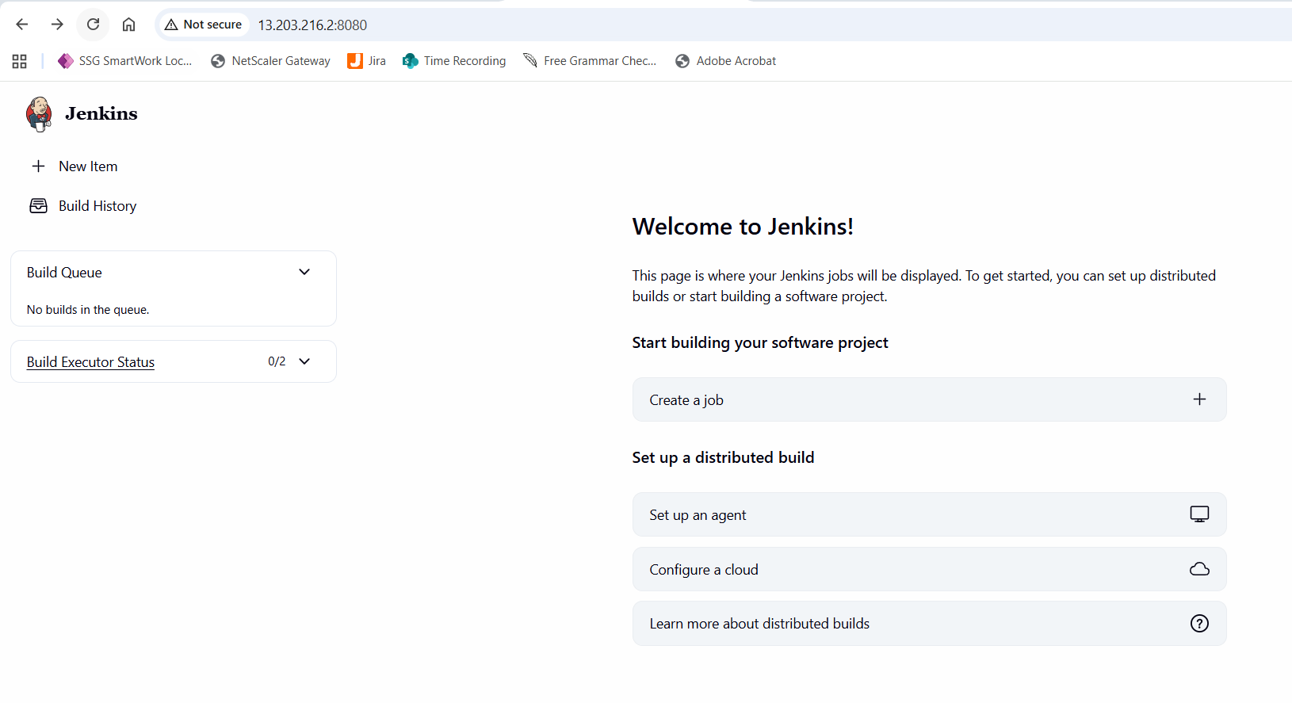

Created a freestyle project called guvi.
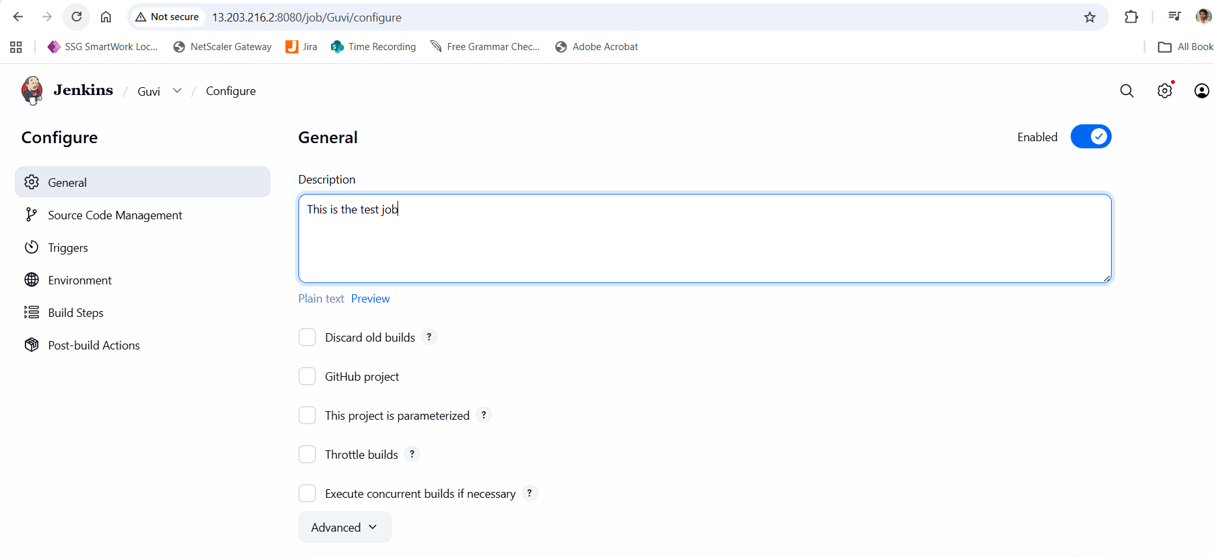
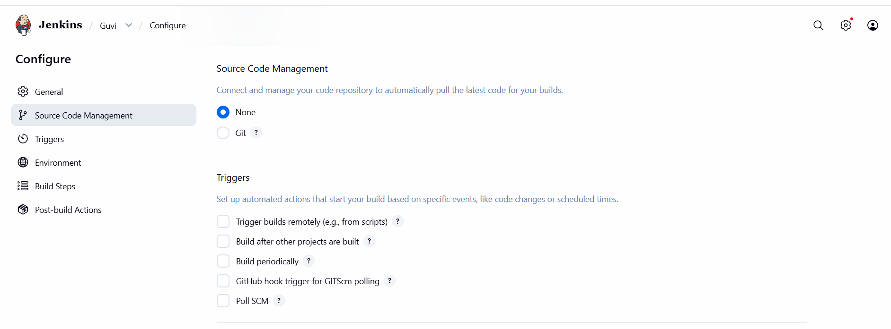
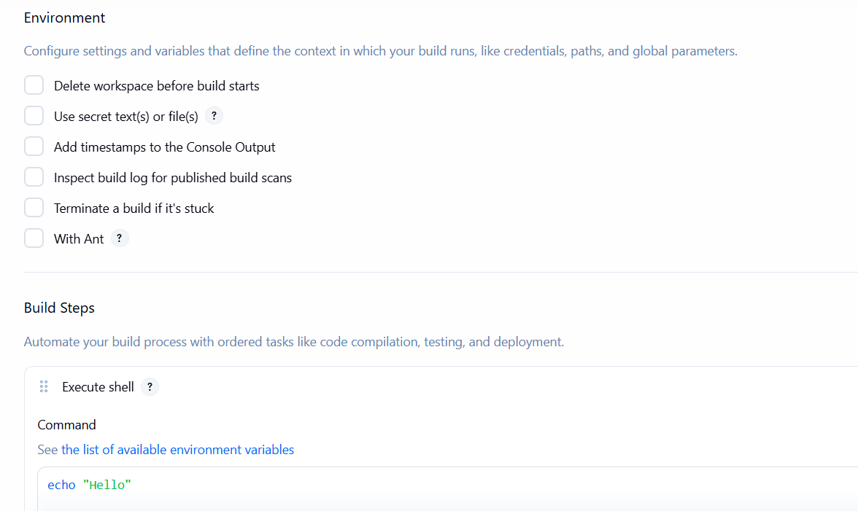

Run the pipeline by clicking on the “Built Now”

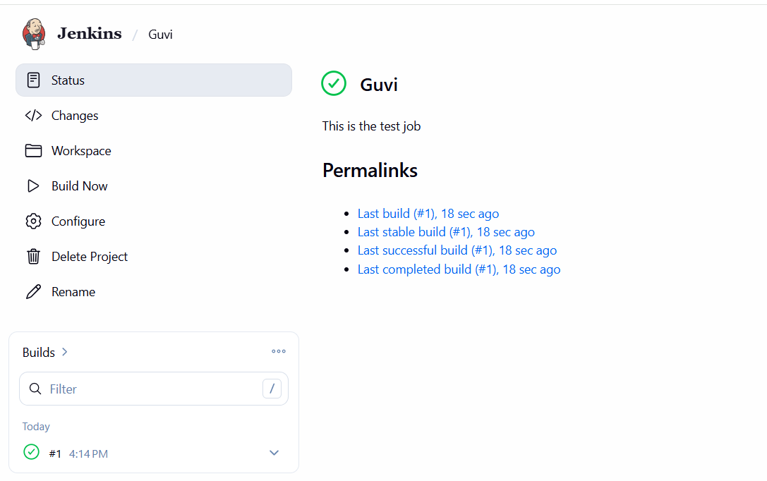
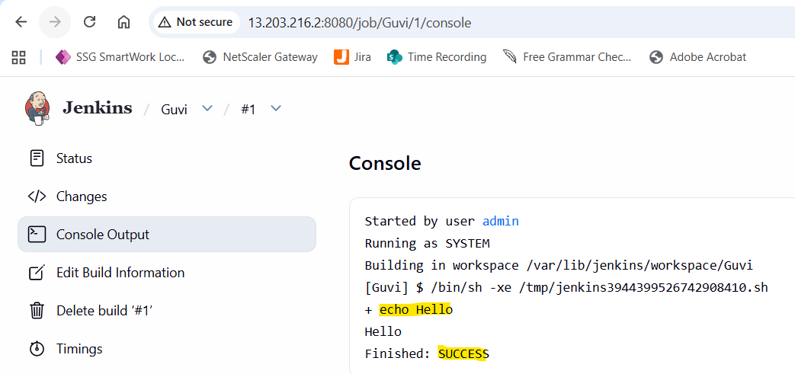

Create the user.
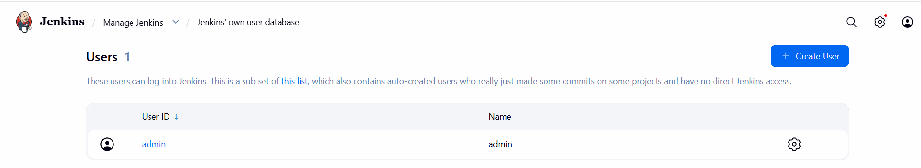
New users got created.
